# Exercise: Networks, Internet and Protocols

Problems for exercises and homework for the ["Software Technologies" course @ Software University.](https://softuni.bg/trainings/4086/software-technologies-may-2023)

## Trace the route to a certain IP address

1. Use the ping command to test connectivity to an external website of your choosing /Example: wikipedia.com/

2. Add a screenshot of the result here:

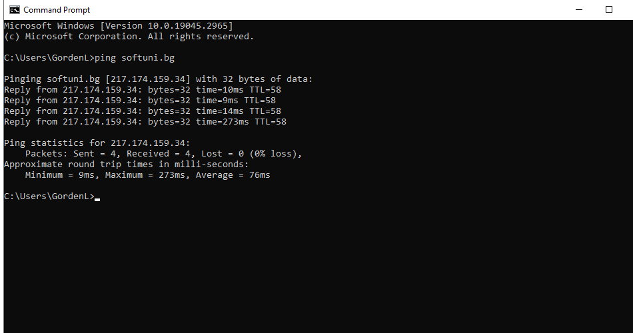 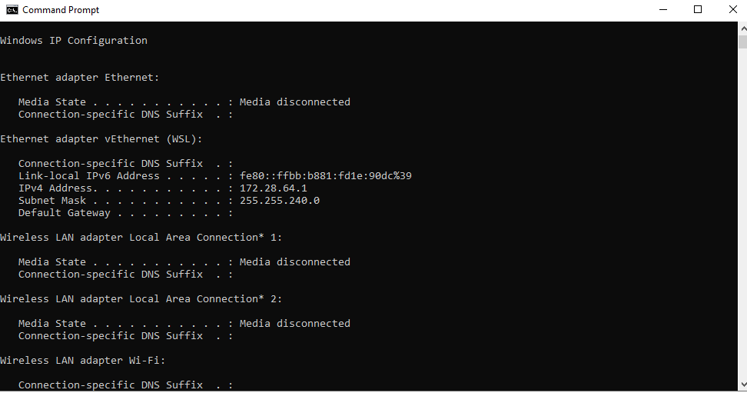

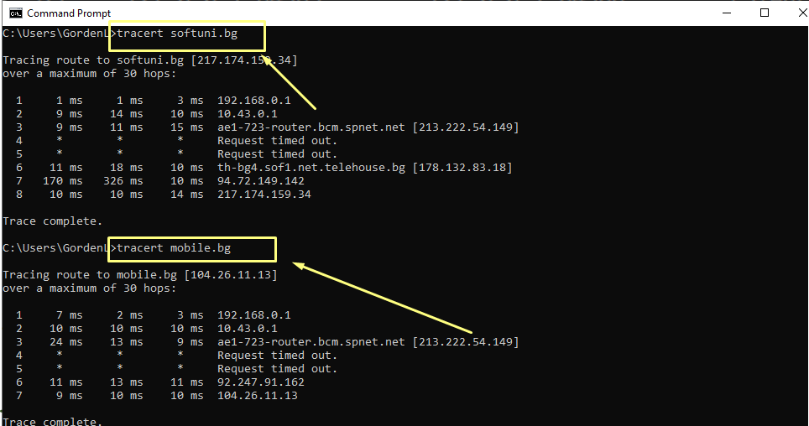

## Find the IP address behind a domain name

1. Using an online DNS lookup tool, like **DNS Checker** or **MX Toolbox** find the IP address of a domain. /Example: medium.com/

2. Add a screenshot of the result here:

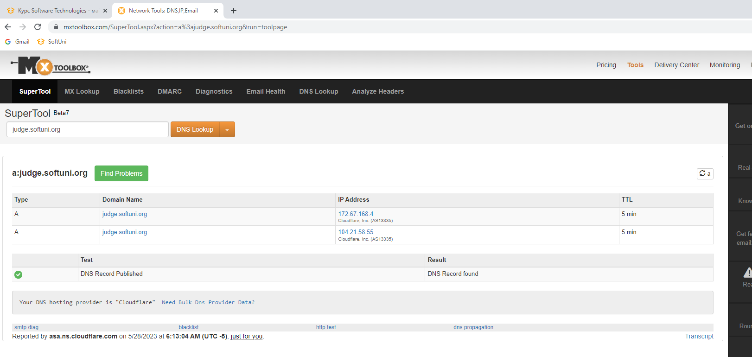

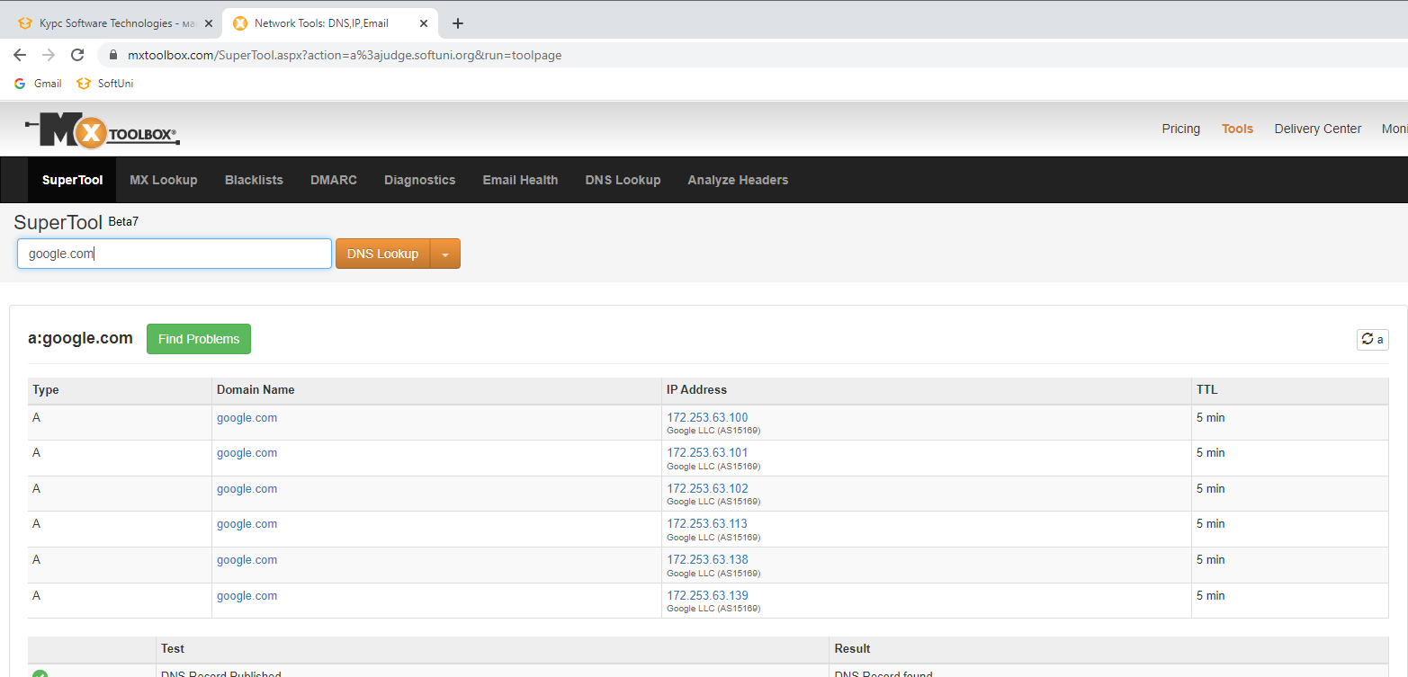

## Execute HTTP GET

1. Using **<https://restcountries.com/>** and DevTools on your browser. Execute a GET request for a country of your choosing. /Example: https://restcountries.com/v3.1/name/deutschland/

2. Add a screenshot of the result ­with DevTools open here:

